1. **Agenda:**
   1. We will update createProduct(…) in controller class to make it handle exception.
2. 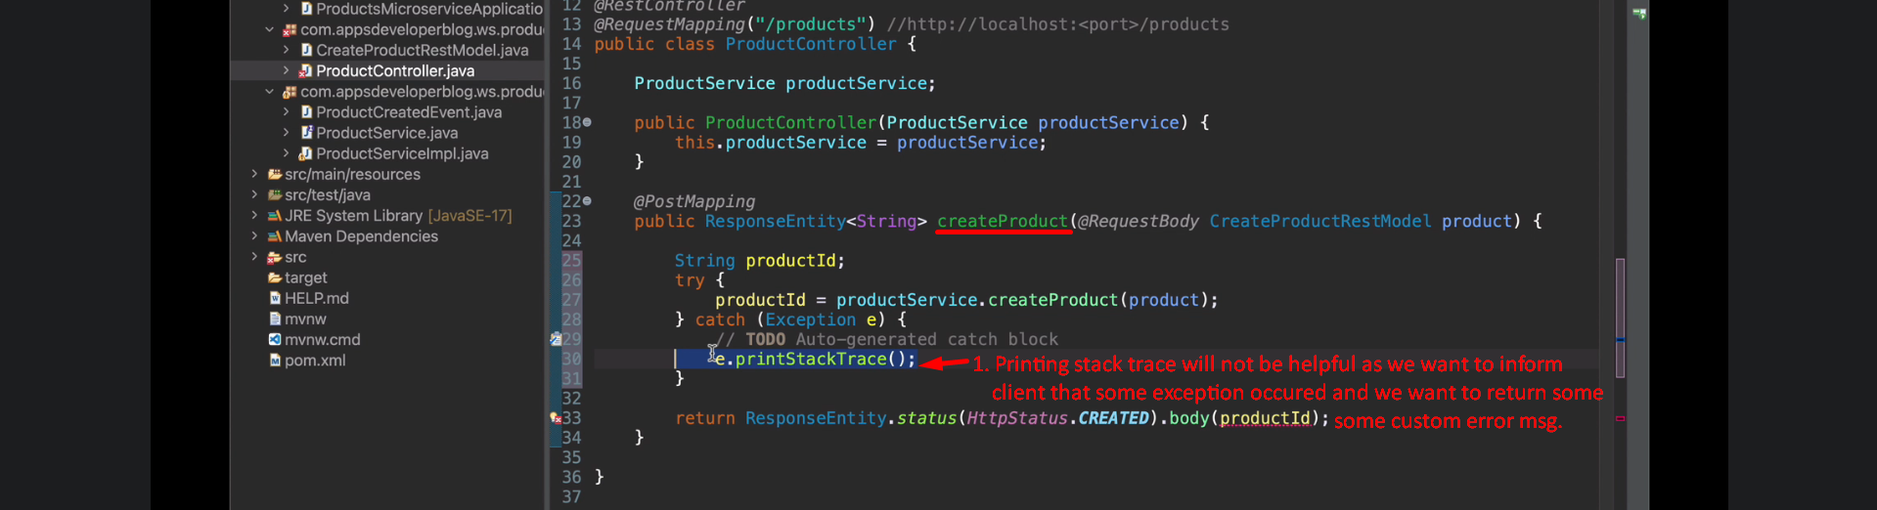
3. 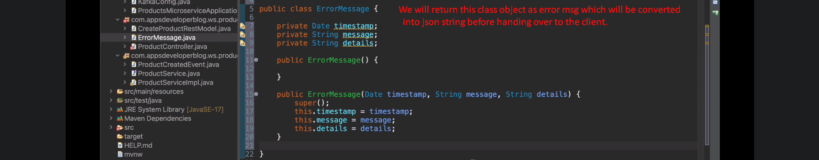
4. 